Software Requirements Specification
for
<Moodle>
Version 1.0 approved
Prepared by <Petri Jokinen, Tapio Niämi, Henri Lehtimäki, Jari Rönkä>
<Kamk University of applied sciences>
<2.2.2016>
Table of Contents
Table of Contents ii
Revision History ii
1. Introduction 1
1.1 Purpose 1
1.2 Intended Audience and Reading Suggestions 1
1.3 Product Scope 1
1.4 References 1
2. Overall Description 2
2.1 Product Perspective 2
2.2 Product Functions 2
2.3 User Classes and Characteristics 2
2.4 Operating Environment 2
2.5 Design and Implementation Constraints 2
2.6 User Documentation 2
2.7 Assumptions and Dependencies 3
3. External Interface Requirements 3
3.1 User Interfaces 3
3.2 Hardware Interfaces 3
3.3 Software Interfaces 3
4. System Features 4
5. Other Nonfunctional Requirements 4
5.1 Performance Requirements 4
5.2 Safety Requirements 5
5.3 Security Requirements 5
6. Other Requirements 5
Appendix A: Glossary 5
Appendix B: Analysis Models 5
Appendix C: To Be Determined List 6

Revision History
Name | Date | Reason For Changes | Version

Introduction

Purpose
The purpose of this document is to describe the requirements of Moodle education software .

Intended Audience and Reading Suggestions
The intended readers of dis document are the developers of the software, testers, end-users and teachers.

Product Scope
Moodle education software is a system for educational purposes.
Designed to be used by teachers and students.

References
example of a software requirements specification document.
http://www.slideshare.net/KrishnasaiGudavalli/software-requirements-specification-17173967

Overall Description

Product Perspective
Moodle is a system to share information and data through web interface.
That way allowing students to follow courses from anywhere.
Also designed to lessen the paper work needed.

Product Functions

Admins
Admin should be able to modify the functions of software.
Remove content and users.
Release and edit data.
Edit other user profiles access to software.

Teachers
Add and edit courses and data contained in them.
Access shared data on courses
Post answers to courses

Students
Access shared data on courses
Post answers to courses

User Classes and Characteristics
Users of Moodle system are students, teachers and the administrators who maintain the system.
Students and teachers are assumed to have basic knowledge of computers and internet.
Administrators should have more knowledge on the internal parts of the system and be able to repair and develop fixes for the system.

Operating Environment
Moodle is website service and should operate on most of the used web browsers without causing an error to the user interface.

Design and Implementation Constraints
The information of all users, courses and course material must be stored in a database that’s accessible by the website.
The system is required to be available 24h a day excluding maintenance breaks.
Must be accessible from any computer that has access to internet.
Users are required to have correct usernames and passwords to access the site and course information.

User Documentation
The system has a list of usual technical problems and how to fix them, in other situations the user is required to contact the system administrators for help.

Assumptions and Dependencies
The product needs the following third parties:
24h a day online webserver and database.
System maintenance and integration software. (DLC sold separately)

External Interface Requirements

User Interfaces
Search Courses
- This way you can search courses, that teachers have added to Moodle
Course overlay
- You can see what courses you have added to your overlay
Navigation
- You don’t get lost in Moodle, because you have navigation and you can see your course overlay from here also.
Latest News
- There is notifications for example: maintenance breaks
Instructions
- Information to everything, for example: helpdesk and Getting started.

Hardware Interfaces
No specific hardware requirements for running this software.

Communications Interfaces
FTP, HTTP

System Features
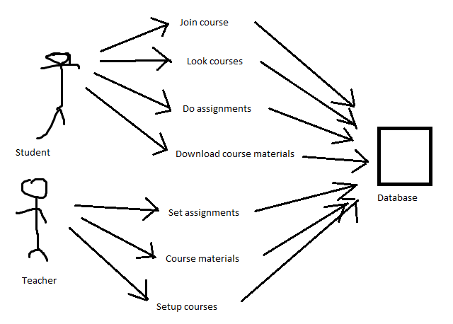

Other Nonfunctional Requirements

Performance Requirements
The system shall accommodate high number of students, teachers, courses and course materials without any fault.

Safety Requirements
Software use shall not cause any harm to human users.

Security Requirements
System will use secured database and connections
Student users can just read information but cannot edit or modify anything un-accessible to them. Teacher users can edit and modify courses and information.

Other Requirements
The servers that might have personal data has to be located in Finland
Appendix A: Glossary
<Define all the terms necessary to properly interpret the SRS, including acronyms and abbreviations. You may wish to build a separate glossary that spans multiple projects or the entire organization, and just include terms specific to a single project in each SRS.>
Appendix B: Analysis Models
<Optionally, include any pertinent analysis models, such as data flow diagrams, class diagrams, state-transition diagrams, or entity-relationship diagrams.>
Appendix C: To Be Determined List
<Collect a numbered list of the TBD (to be determined) references that remain in the SRS so they can be tracked to closure.>

